2023-2024学年第二学期《液压与气动传动》期末考试
B卷答案及评分标准

I Fill in the blanks: (10 points, 1 point for each blank)
1．equation of equation equation of energy (equation of Bernoulli)
conservation of momentum
2．precompression of the spring
3．volume loss
4．Load Flow rate
5. Leakage Radial unbalance force surrounded oil

II Short answer: (30 points, 5 points for each question)
1. In the hydraulic system, when the pressure of the flowing liquid somewhere is lower than the air separation pressure, the air originally dissolved in the liquid will be free, so that a large number of bubbles in the liquid, this phenomenon is called the cavitation phenomenon.
2. (1) a sealed working chamber;
(2) The volume size of the sealing working chamber changes alternately, the larger it is connected with the oil suction port, the smaller it is connected with the oil pressure port;
(3) The oil suction port and the oil pressure port cannot be connected.
3. (1) Displacement refers to the volume of oil that can be discharged when the pump shaft is turned around without leakage;
(2) The theoretical flow rate is the volume of oil output per unit time in the absence of leakage;
(3) The actual flow rate refers to the actual output volume of oil per unit time.
4. (1) The pressure reducing valve keeps the pressure at the outlet basically unchanged, and the relief valve keeps the pressure at the inlet basically unchanged.
(2) When not working, the inlet and outlet of the pressure reducing valve are interconnected, and the inlet and outlet of the relief valve are blocked.
(3) In order to ensure that the outlet pressure setting value of the pressure reducing valve is constant, its pilot valve spring chamber needs to be separately connected to the external oil tank through the oil drain port; The oil outlet of the relief valve is through the tank, so its pilot valve spring chamber and the leaking oil can be connected through the channel and the oil outlet on the valve body, without having to connect the external tank (of course, it can also leak).
5. (1) Working principle: By changing the size of the flow control element (throttle valve or speed regulating valve) in the loop through the flow cross-sectional area to control the flow into the actuator or self-executing element to adjust its speed of movement.
(2)According to the different positions of the flow valve in the loop, it can be divided into inlet throttle speed control loop, return throttle speed control loop and bypass throttle speed control loop.
6. (1) as an auxiliary power source;
(2) Maintain system pressure;
(3) Reduce hydraulic shock or pressure pulsation.

III Calculations. (25 points)
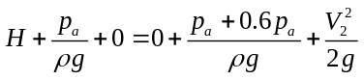1.Bernoulli equation for sections 1-l and 2-2 when the valve is fully open：

When the valve is closed, based on the reading of the pressure gauge, use the fundamental equation of fluid statics to calculate the H value：
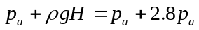

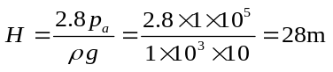

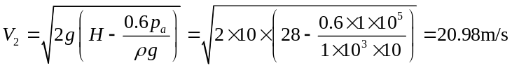

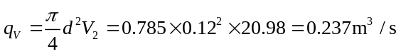

（2 points for every step）

2.Figure A Pressure Calculation：
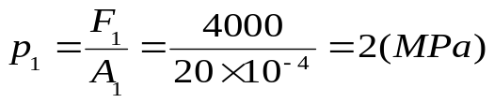
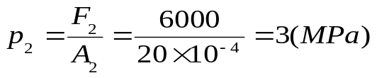
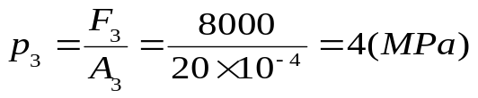
（1）py=2.5MPa，p3>p2>py，So only hydraulic cylinder 1 works。
（2）py=5MPa，py>p3>p2>p1，All work, hydraulic cylinders I, II, and III work in sequence
（3）Figure (a) Hydraulic cylinders I, II, and III work in sequence
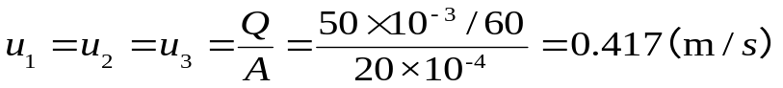
Figure (b) Each hydraulic cylinder moves simultaneously but at different speeds
The flow rate into hydraulic cylinder III is equal to the flow rate of the hydraulic pump Q=50 L/min；
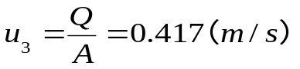
Flow rate into hydraulic cylinder II Q₂
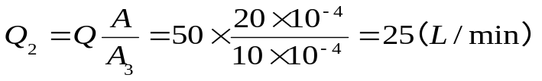
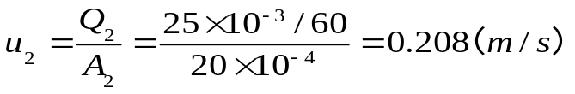
Flow rate into hydraulic cylinder I Q₁
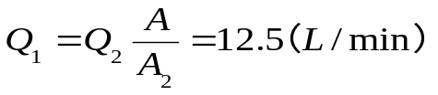
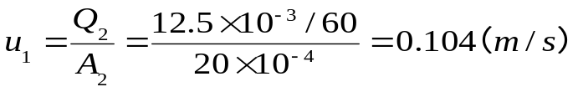

（5 points for every question）

IV Diagramming question. (20 points)

（1）
Hydraulic basic circuit | Sequence action circuit
Component A | Non-return valve (Check valve)
Component B | Sequence valve
Component C | Three-position, four-way directional control valve

（2）
Hydraulic basic circuit | Bypass throttle speed-regulating circuit
Component A | Hydraulic cylinder
Component B | Throttle valve
Component C | Reservoir

（3）
Hydraulic basic circuit | Fast speed circuit
Component A | Pressure relay
Component B | Accumulator
Component C | Two-position, two-way directional control valve

（4）
Hydraulic basic circuit | Locked circuit
Component A | Hydraulic operated non-return valve (Check valve)
Component B | Relief valve
Component C | Pump

（5 points for each question）
V Analysis. (15 points)
- In fast forward, the oil inlet circuit is: hydraulic pump 1→ check valve 2→ three-position five-way electromagnetic directional valve 5 (left) → hydraulic cylinder 9 left chamber. The oil return circuit is: hydraulic cylinder 9 right chamber → hydraulic control check valve 6→ three-position five-way electromagnetic directional valve 5 (left) → hydraulic cylinder 9 left chamber. The basic circuit used is the differential connection circuit.
- The oil inlet circuit is: hydraulic pump 1→ check valve 2→ three-position five-way electromagnetic directional valve 5 (left) → hydraulic cylinder 9 left chamber. The oil return circuit is: hydraulic cylinder 9 right chamber → speed control valve 7→ oil tank. The basic circuit used is the return oil throttling speed regulating circuit.
- The feed circuit at fast retreat is: Hydraulic pump 1→ check valve 2→ three-position five-way solenoid directional valve 5 (right) → liquid-controlled check valve 6→Hydraulic cylinder 9 right chamber. The oil return circuit is: hydraulic cylinder 9 left chamber → three-position five-way electromagnetic directional valve 5 (right) → check valve 4→ oil tank.

（5 points for each question）

